Affordable & Sustainable
Housing Project:

(ASH) This is temporary name for this project. We seek to be much more than affordable and sustainable, but these two important goals speak to our commitment to economic justice and sustainability. We will pick the permanent name when we find the partners we need to do so.

We are at the beginning of a very big dream. You are invited to help realized this dream – a living community committed to creating a better world.

Our current ecological and societal conditions demand profound and powerful changes, if we are going to survive and pass on to the next generation, anything resembling a livable world.

We believe that it still might be possible to turn things around and move in the direction of compassion, care, beauty, balance, and the vibrant survival of our species.

As a human family, we need to re-invent ourselves – completely. Every aspect of our lives – our homes, our workplaces, how we move through the world, our food systems, our energy systems – everything. It all needs to change, and we need to do so quickly.

The ASH Project seeks to embody these needed changes at the foundation of our lives – where we live and how we engage with each other at home and in the community around us.

Solving Problems - Living Solutions: Here is a short outline of some of our problems and how ASH will address them:

- Poverty & Homelessness – The ASH community will provide units and a compassionate community that will help people transition to stable housing.
- Soaring Housing Costs – By sharing common spaces and shrinking private spaces, ASH will reduce and share housing costs more equitably.
- Climate Emergency – Using renewable energy, conservation measures, shrinking room sizes, employing “net-carbon-zero” technologies, and sharing resources, we will demonstrate how to truly live sustainably.
- Racial disparities and segregation – We will promote active healing from our racist culture by supporting racial justice, and intentional diversity within our community.
- Isolation and Loneliness – Our community spaces with be places of community support, mutual aid, healing and solution-based action.
- Noise and confusion – We will design our building with sound-proof technologies, and we will create a culture of awareness and respect for our shared spaces.
- Meeting of Needs – Part of our community’s mission will be to share in the work of meeting the needs of others. To each, according to need – from each, according to ability.

Equity-based Cooperative Community:
A Pathway to Ownership for All!

We believe that communities should be owned by the people living in them. Though there will be options for renters and guests in some ASH units, most of the units will be privately owned by the residents living in them. We seek to provide a pathway to ownership for very member of our community regardless of economic status.

Something for Everyone
The ASH community hopes to be a place where all people can thrive and feel a sense of belonging regardless of their unique needs, abilities, wants, talents, strengths, or struggles. ASH will strive to provide the following:

- A variety of unit sizes including studios and single rooms that will provide an entry level for low-income individuals to become owners.
- A variety of involvement options. Not everyone has the ability or desire to be involved in community meetings or community activism. Though these will be supported by ASH, they won’t be a requirement for anyone.
- Opportunities to share space, talents, and other resources as well as the sanctuary of one’s own quiet, clean, private unit.
- Opportunities to engage with the surrounding community with service, hospitality, and/or community organizing.

A Living, Learning, Loving, Laboratory!

We will create a place to explore creative solutions to today’s most challenging problems, in ways that are infused with the love of a committed community.

Everywhere we turn, people are hurting - children living under poverty, abuse, and neglect; people medicating themselves in harmful ways; gun violence; human trafficking; people living in toxic environments…

While our government wastes money and resources on war, we fail to meet the needs of those in need. Our culture and the corporate dominated media tell us that the answer is to buy and consume more stuff.

We know that there is a better way. We know that the solutions are based in community committed to grassroots democracy and in demonstrating the solutions that the world needs now.

Imagine how different the world would be if we all came home to safe and loving communities committed to making the world a better place. What if we all decided that we were not going to leave anyone out.

A Room with a View

We don’t know if ASH will be a small or large community. Many of us hope that it will be tall so that we can share the common top floor and enjoy the view of our beautiful world.

If not us, who? If not now, when?

The challenges that that humanity faces are vast! The science of our current climate crisis is terrifying. All we can do is resist the current complacency of our dominant culture and try our best to show the world more hopeful solutions and hope that we can help to wake-up the world.

Though ASH is just getting started, we believe that in the next 2 - 4 years we will be ready to break ground.

Our fist step is to find the people who will help to make this all possible.

If you are a person who loves people, knows that the ways that we are living aren’t working, and you want to be part of the solutions, consider being a part of the ASH Project. Perhaps you will even help us pick our permanent name.

To learn more about this project:

Tim Cordon, 608-233-9774 ext. 125
timc@fusmadison.org

Abby Davidson,
abby.s.davidson@gmail.com

Paul Schechter, 608-239-8500
paul@Sunnysidedevelopment.org

Oct. 2019

Imagine what would be possible, if we pulled together, and built a living community based on LOVE…

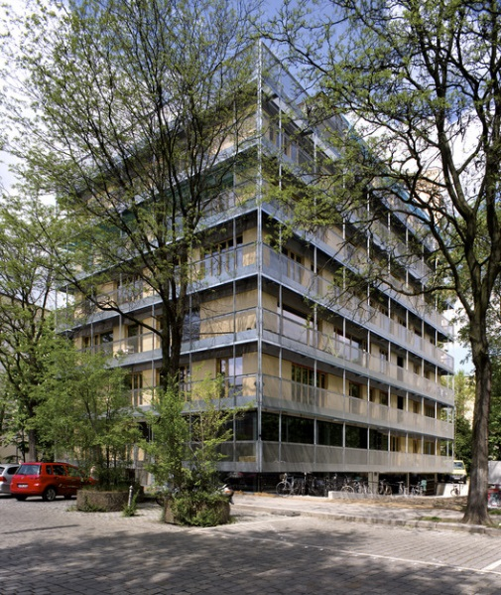

Affordable &
Sustainable Housing
(ASH Project *)

"The greatness of a community is most accurately measured by the compassionate actions of its members."
– Coretta Scott King

* The temporary name for a project to create one or more intentional cooperative communities in the areas of Milwaukee and/or Madison, Wisconsin.

